**Project Design Phase-II**

**Data Flow Diagram & User Stories**

|  |  |
| --- | --- |
| Date | 23 october 2023 |
| Team ID | NM2023TMID01019 |
| Project Name | DRUG TRACEABILITTY |

**Data Flow Diagram :**

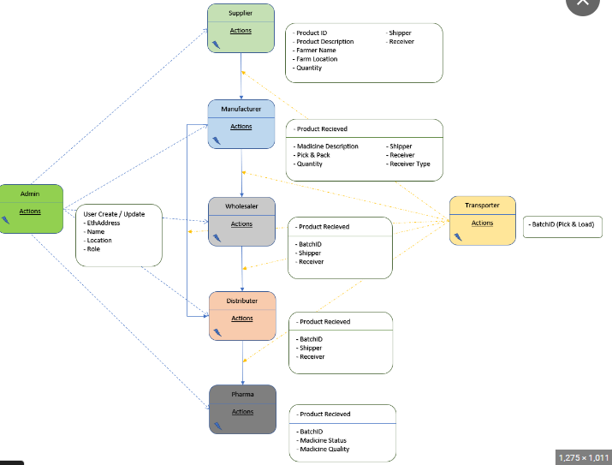

Blockchain is a new and reliable technology that helps with security, preservation and reliability of data. Libraries are change agents of the 21st century and are implementing new technologies to provide maximal information in minimal time. Blockchain technology can be used to solve different problems in the library field with proper usages for storing information in a distributed tamper-resistant setting. Blockchain in library settings can be used to gather, preserve and share authoritative information devoid of many technological hurdles. Some challenges such as finance, technical and security issues are troubling factors, but proper training, support from decision makers and technical skills regarding this technology will pave the way for library practitioners.

Characteristic of blockchain technologies

Some key characteristic of blockchain technologies are listed as follows:

* Increased capacity: Blockchain technology can increase the capacity of an entire network. One such example is the supercomputer created by Stanford University used for medical research.
* Better security: Blockchain technology offers better security as it provides for a network of numerous computer nodes that can be used for networking transactions .
* Immutability: Blockchain uses immutable ledgers, and all databases require trust of a third party to keep them secure from hackers. Blockchain applications, such as Bitcoin, maintain the ledger in a never-ending state of forward momentum.
* Faster settlement: Blockchain technology relies on faster speeds and saves time for institutions and consumers. One example from banking is that blockchain makes money transfer fast and convenient.
* Decentralized System: Blockchain technology offers a decentralized system that stores the assets in a network and can be accessed via the internet. The asset may be a contract or document of importance. The manager of blockchain technology has control over the accounts of individuals and can transfer anything to anyone. This technology is proving to be an effective tool for decentralizing the web.
* Minting: Blockchain technology involves minting a problem in several ways. Proof of work is one approach guaranteeing an individual is engaged in a significant amount of computation work.

**USER STORIES:**

User Registration and Authentication:

As a pharmaceutical company representative, I want to register my company's details and authenticate securely to access the PharmaTrace system.

As a regulatory authority personnel, I want a user account and secure authentication to oversee drug traceability in the system.

Data Entry and Management:

As a pharmaceutical company, I want to input drug information, including unique identifiers, names, batch numbers, production dates, and expiration dates. As a distributor, I want to update drug information when the ownership of a batch changes.

Ownership Transfer:

As a distributor, I want to initiate an ownership transfer of a batch of drugs to another distributor, recording the transaction securely on the blockchain.

Data Query:

As a regulatory authority, I want to query drug information to ensure the authenticity and traceability of pharmaceutical products. As an auditor, I want to perform audits by querying specific drug data and reviewing the audit trail.